**Establish the connection b/w Jenkins master and Slave servers without key pair:**

* Create the two ec2 instance one for Jenkins master with key pair and another for slave server without key pair(take t2.medium).
* Install the java and Jenkins on master server and install the only java(java 17)on slave server.
* Go to .ssh folder and generate the public and private key by using **ssh-keygen** command.
* Enter **ll** command and it shows public and private keys.
* Open the public key by using **cat publickey name** command and copy this public key and paste it on slave sever at authorized keys file in the root user.
* Log into Jenkins dashboard and go to manage Jenkins > Nodes.
* Create the node and while configuration of the node we can add the user name as root and paste the private key (we can generate in the master server).
* Create the job like freestyle or pipeline and we can select and give node label name at **Restrict where this project can be run** option.
* Click on **add buils step** option and click on **execute shell** and write the shell script.Click on apply and save option.Click on Build now option.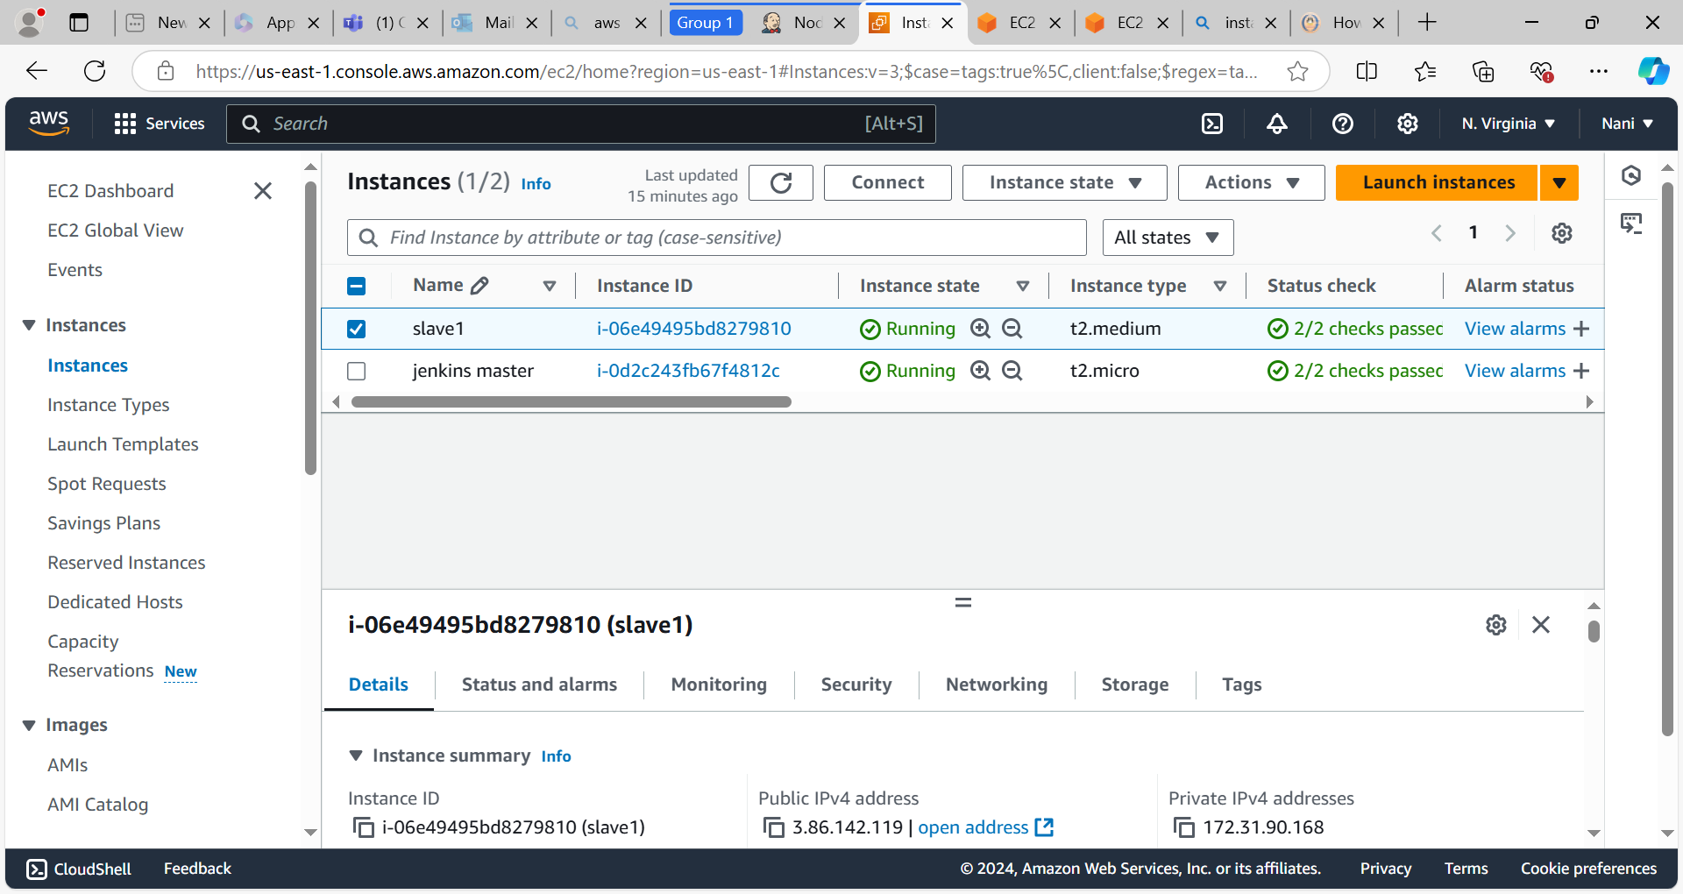

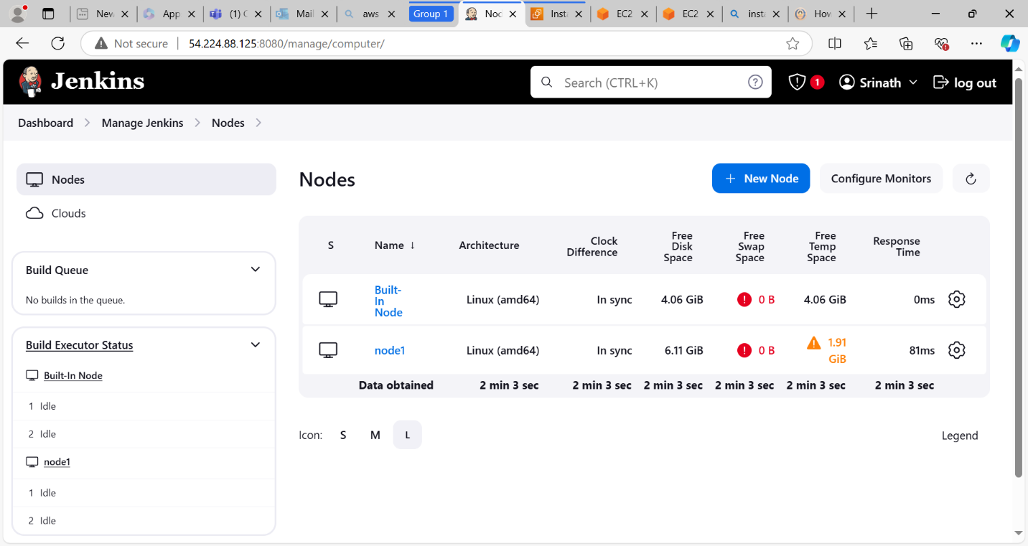

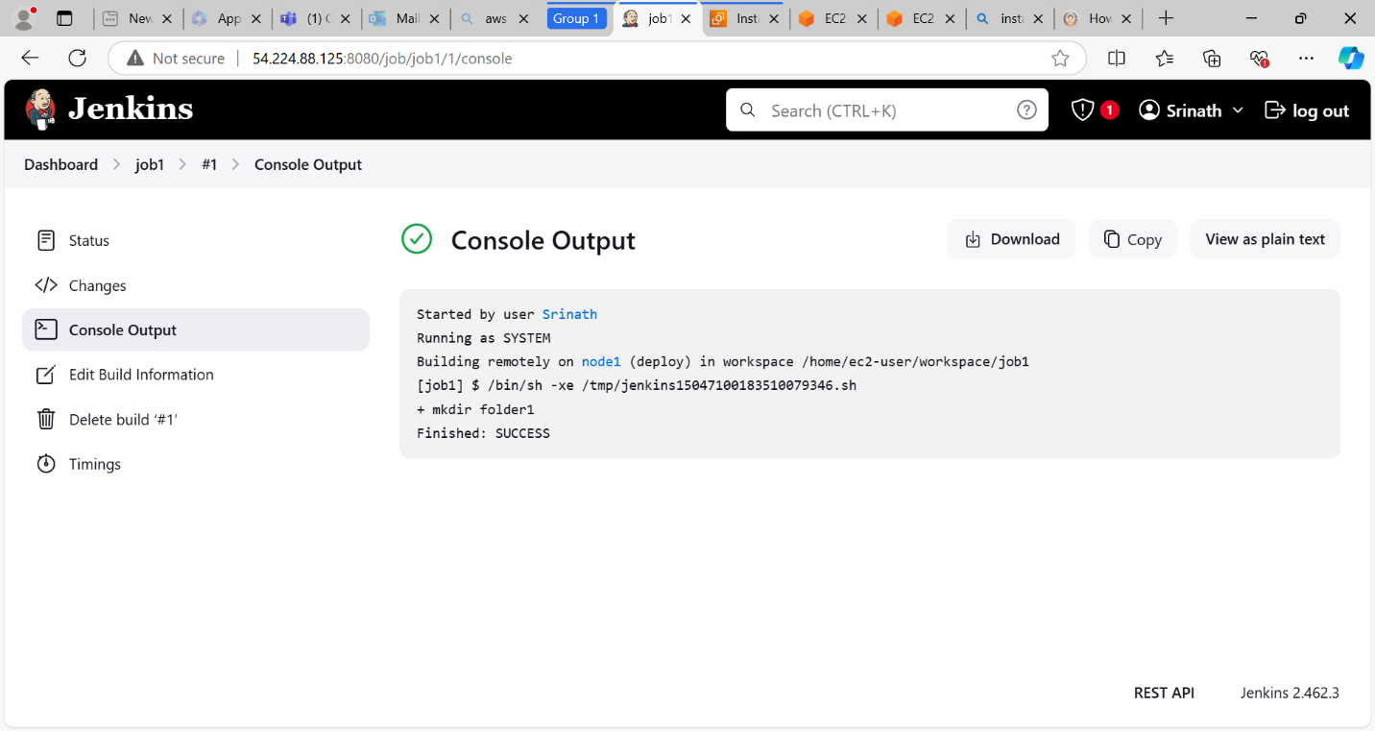

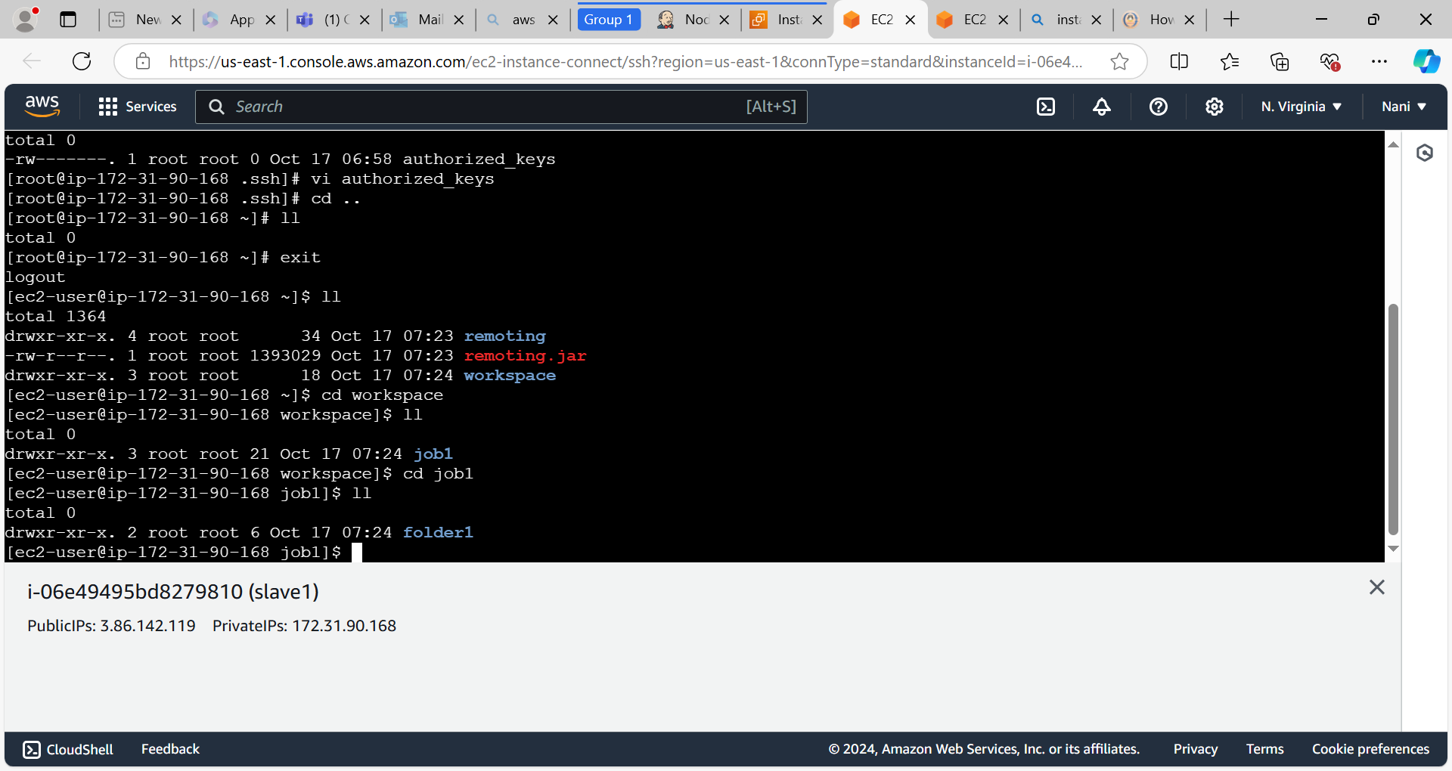

**Backup the Jenkins by using thinbackup plugin:**

* Inside the **.jenkins** folder (which is available on /var/lib) all the information about Jenkins like jobs,nodes,plugins,config file,secrets etc.is available.
* We need to backup the .jenkins to the other folder(create new folder) or external service like store the data on ebs volumes by using **thinbackup** plugin**.**
* Create the one directory(backupfolder) in opt directory for backup the data on master server.
* Change the ownership and group name by using **chown username:groupname foldername** command.

Ex: chown Jenkins:Jenkins backupfolder

* Change the file permissions by using **chmod 777 foldername** command.
* Go to Jenkins dashboard and go to managed Jenkins > plugins install **thinbackup** plugin if it is not available.
* Thinbackup plugin is available under **Tools and Actions** section.
* After installation configure the this plugin on **system configuration** section.
* We need to give the directory name(/opt/directoryname in this case) where we want to store the backup data while configuration of thinbackup plugin.
* Go to **tools and actions** section click on **thinbackup** plugin and click on **backup** **now** option.
* Data will be store at that directory which we have mentioned while configuration in the system configuration section.

